Appendix One – Foresters Tower PSPO

ANTI-SOCIAL BEHAVIOUR, CRIME AND POLICING ACT 2014

PART 4, SECTION 59

PUBLIC SPACES PROTECTION ORDER

Oxford City Council makes this Order, being satisfied on reasonable grounds that activities in the location described in paragraph 2 of this Order have had or are likely to have a detrimental effect on the quality of life of those in the locality, and that these activities involved various anti-social behaviours. Further, Oxford City Council believes that the effect, or likely effect, of the activity described in paragraph 1 of this Order is (or is likely to be) persistent in nature, such as to make the activity unreasonable and justifies the restriction imposed by this notice.

Oxford City Council hereby requires by way of this Order that:

- The activity described below is hereby prohibited as from the date of this Order:

Young people under the age of 21 years not legally resident in Foresters Tower are prohibited from entering (or having entered, remaining within) Foresters Tower, Woodfarm, Oxford unless visiting a named legal resident of Foresters Tower.

2 The land in relation to which this Order applies is that land in the area of Oxford City Council namely which -
- is delineated and shown in red hatching on the map forming part of this Order, and
- is briefly described in the Schedule to this Order.

3 If without reasonable excuse you breach the prohibition in paragraph 1 you may be prosecuted. If you are prosecuted and convicted the maximum penalty is a fine not exceeding level 3 on the standard scale (currently ₤1,000).

4 This Order shall remain in place until 2018

Dated | 2015
Signed | TIM SADLER  EXECUTIVE DIRECTOR COMMUNITY SERVICES  CHRISTIAN BUNT  SUPERINTENDANT – THAMES VALLEY POLICE

SCHEDULE

ALL COMMUNAL AREAS WITHIN FORESTERS TOWER, WOODFARM, OXFORD, OX3 8QA

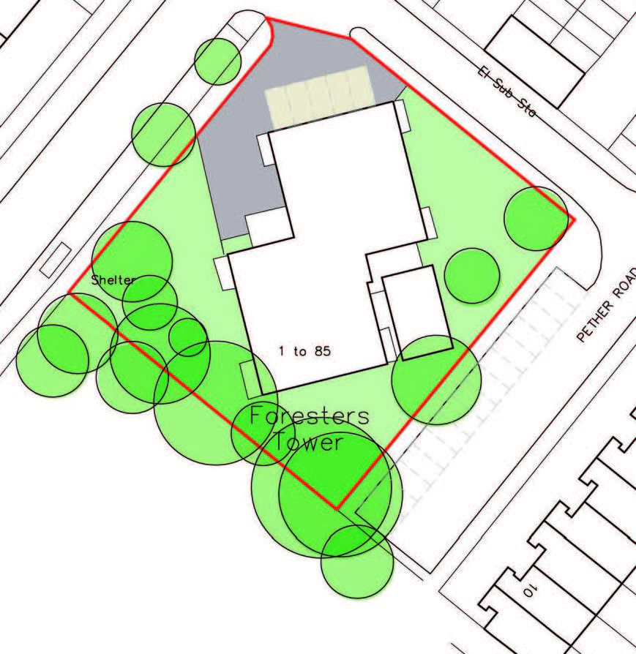

CHALLENGING THE VALIDITY OF ORDERS
An interested person may apply to the High Court to question the validity of—
- This Order, or
- A future variation of this Order.
“Interested person” means an individual who lives in the restricted area or who regularly works in or visits that area.

An appeal against this Order or a future variation of this Order may be made to the High Court within six weeks from the date on which the order or variation is made, on the grounds that:
- Oxford City Council did not have power to make the order or variation, or to include particular prohibitions or requirements imposed by the order (or by the order as varied);
- a requirement under Chapter 2 of the Anti-Social Behaviour, Crime and Policing Act 2014 was not complied with in relation to the order or variation.

